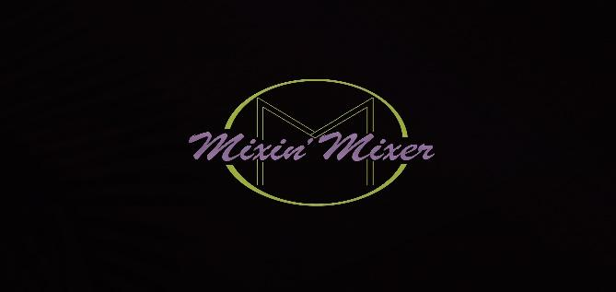
Rethmiriam Barr
843 614-1632
8605 Grassy Oak Trl.
North Charleston, SC 29420

Meet your mixologist …
1. Certification:
- All mixologists are T.I.P.S.-certified

2. Capacity & Pricing:
- One mixologist is required for every 50 guests
- Initial fee: $195 for the first three hours of service
- Additional Hours: $35 for each hour thereafter

3. Complimentary Items for beer and wine bar and full bar service:
-Tables
- Standard black linens for the bar setup
- Plastic cups and beverage napkins

4. Environmental Consideration:
- No plastic stir straws provided to protect sea turtles

The Brew Cellar $10.75
Maximum guests 75
1 Mixologist - $195 per 50 guests
Wine
Cabernet Sauvignon or Pinot Noir (red)
Chardonnay or Pinot Grigio (white)
Upgrade $2.25 per person for sweet wines
Moscato
Riesling
*Add on Sparkling Wine $1.50

Beer (select 2)
Michelob Ultra, Corona or Stella Astrios~ upgrade ~ Heineken
$1.00
Upgrade IPA $1.50

*Add on for a signature cocktail $5.75

Mixology Lounge $13.75 per person
Maximum guests 75
1 Mixologist - $195 per 50 guests

Liquors
Vodka
Tequila
Whisky
Bourbon
Rum

Select 2 Beers
Michelob
Corona
Bud Light

Additional add ons for $2.00 per person
Stella Artois
Heineken
Modelo

Chasers
Sprite
Coke
Diet Coke
Ginger Ale
Cranberry juice
Orange juice

Garnishes
Lemons
Limes
Cherries

Additional add Ons
*Pineapple juice~$1.00
*Add on Sparkling Wine ~ $1.50
*Add on for a signature cocktail~ $5.75

Virgin Mixery $7.75
Maximum guests 75
1 Mixologist - $195 per 50 guests
Select two Flavors

Lemonade Flavors
Legacy lemonade (Passion fruit and Mango)
Ginger Lemonade
Strawberry lemonade
Lemonade

Tropical Flavors
Jamaican punch (Orange, pineapple and lime)
Watermelon Basil (watermelon, lime juice, and basil)
Cherry on top (Guava juice, lime juice topped with cherry syrup)
Orangefall (orange favored, lime and rosemary)

*Spiked~additional $5.00 per person

Mixologist only
$250
3 hours
$30 for each additional hour
“at your service”

Mixologist Service
1. Certification:
- All mixologists are T.I.P.S.-certified and insured
2. Capacity & Pricing:
- One mixologist is required for every 75 guests
- Initial Charge: $250 for the first three hours of service
- Additional Hours: $35 for each hour thereafter

3. Items provided with this service:
- Standard black linens for the bar setup
- Plastic cups and beverage napkins
(tables provided with an additional charge)

4. Environmental Consideration:
- No plastic stir straws provided to protect sea turtles

If you need assistance with anything specific regarding this service or would like to expand on this information, please let me know!

*Rate will increase when booked outside of the two week window.

